Farmers: what’s in your
weed seedbank?

We have funding to analyze weed seedbanks of 50 farms in this region. As a participant, you would get:
- a weed seedbank density and composition analysis of one field at your farm
- photos of identifying characteristics of each species
- a tailored weed management plan that addresses your seedbank based on your current equipment and crop selection
- a bar graph depicting the seedbank density of your farm compared to the other anonymous participating farms
- soil nutrient test results from the sample we collect
- a one-time participation payment of $550

We would need to collect a half-gallon soil sample in 2023; some info about your crop/weed management; an hour of your time in 2025 to discuss the results; and 5 minutes for a phone evaluation.

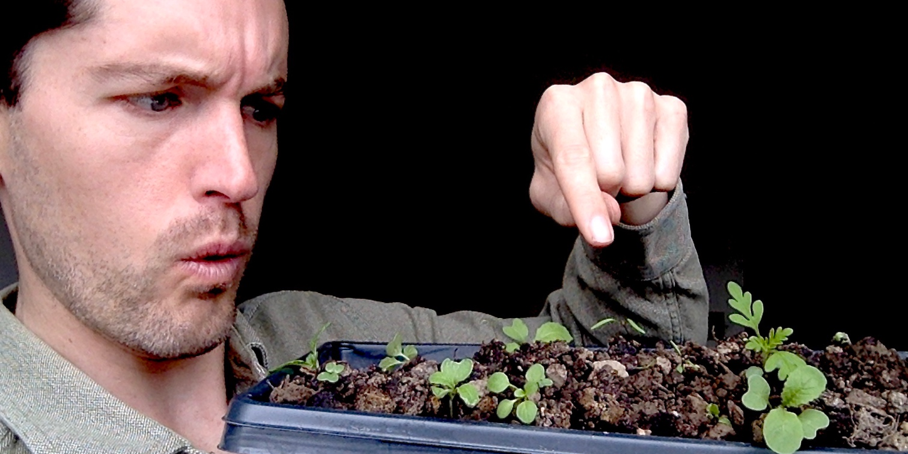

Indicate your interest in participating as soon as possible by emailing Bryan Brown at bjb342@cornell.edu or leaving a message at 315-787-2432. We’re hoping to select a wide range of farms and locations, so please tell us a bit about your farm. We’ll select participants by July 1. There will be a couple forms to fill out, but we’ll try to make it as easy as possible for you.

This work is supported by the National Institute of Food and Agriculture, U.S. Department of Agriculture, through the Northeast Sustainable Agriculture Research and Education program under subaward number LNE23-470-AWD00001024.

